SIMATS ENGINEERING (SAVEETHA SCHOOL OF ENGINEERING)
Department of Computer Science and Engineering
ASSESSMENT TOOL 1 – EXPERIMENTS

Course Code: | ITA05 | Course Title: | COMPUTER VISION
CO Assessed: | CO3 – Precision (BL4) | Assessment: | Assessment Tool 1 – Experiments
Weightage: | 40% of CIA | Total Marks: | 50 (5 Questions × 10 Mark)
CO1 Statement: | Analyze and extract image features using detection and matching techniques for effective image representation and comparison.(BL4).
Student Name: | Madhu Balan I | Reg. No.: | 192321142
Section / Batch: | B-TECH IT | Date:

Code of Conduct
I Madhu Balan I 192321142 (Name / Reg No) certify that this submission is my original work and that I have adhered to the guidelines specified for this assessment. I understand that any violation of academic integrity rules will result in disciplinary action.

Signature of the Student: _________________________

Instructions
- This test contains 5 questions, each carrying 10 marks. Total: 50 Marks.
- No negative marking. Unanswered questions carry zero marks.
- No calculators or electronic devices permitted.
- Duration: 60 minutes.

Section / Topic | Focus | Q Nos | Marks
Types of Image Processing | Point, Neighborhood, Geometric Processing, Applications | 1 | 10
Image Representation | Grayscale, Binary, Color Representation | 2 | 10
Hough Transform | Line Detection, Circle Detection, Parameter Space | 3 | 10
Scale Invariant Feature Matching (SIFT) | Keypoint Detection, Feature Matching, Scale & Rotation Invariance | 4 | 10
Principal Component Analysis (PCA) | Dimensionality Reduction, Feature Selection, Data Representation | 5 | 10
GRAND TOTAL: |  | 50 Marks

Annexure A – Experiments

1.Feature Descriptor Comparison (SIFT vs Harris)
Design and perform an experiment to compare Harris Corner Detection and SIFT feature extraction on the same set of images. Explain the theoretical principles behind corner detection and feature descriptors. Implement both techniques using suitable software/tools, document the detected features systematically, and analyze their performance in terms of feature quality, robustness, repeatability, and suitability for image matching applications.

2.Image Enhancement for Feature Detection
Conduct an experiment to evaluate the effect of image enhancement techniques such as histogram equalization and contrast adjustment on feature detection performance. Explain the importance of image enhancement in computer vision. Apply enhancement methods followed by feature detection using appropriate tools, document the intermediate and final outputs clearly, and analyze how enhancement influences feature visibility, detection accuracy, and reliability.

3.Multi-Scale Feature Detection Analysis
Design and implement an experiment to study feature detection at different image scales. Explain the concept of image scaling and scale-space representation in feature extraction. Apply feature detection methods on images of varying resolutions using suitable software/tools, document the detected features systematically, and analyze the effect of scale variations on feature stability, accuracy, and computational performance.

4.Comparative Analysis of Image Filtering Techniques
Conduct an experiment to compare different image filtering techniques, such as Mean, Gaussian, and Median filtering, for preprocessing. Explain the theoretical concepts and objectives of each filtering method. Implement the filters using appropriate tools/software, document the processed images and observations clearly, and analyze their effectiveness in noise reduction while preserving important image features for subsequent feature detection.

5.Complete Object Detection Workflow
Design and perform an experiment to develop an object detection workflow incorporating image preprocessing, edge detection, feature extraction, and shape detection. Explain the purpose and interaction of each processing stage in the workflow. Implement the complete pipeline using suitable software/tools, document the outputs at every stage systematically, and analyze the effectiveness of the integrated approach in achieving accurate and reliable object detection under different image conditions.

Rubrics for Calculation
Criteria | Weightage (%) | Level 4 (Exemplary) | Level 3 (Proficient) | Level 2 (Developing) | Level 1 (Beginning) | Marks
Understanding of Concepts | 25 | Demonstrates thorough understanding and effectively integrates multiple concepts/technologies | Good understanding with proper integration of most concepts | Basic understanding; limited or partial integration | Poor understanding; unable to integrate concepts
Experimental Design | 30 | Well-planned, systematic implementation with optimal solution | Correct implementation with minor issues | Basic implementation with errors or inefficiencies | Incorrect or incomplete implementation
Use of Tools | 20 | Effective and advanced use of tools/technologies with proper configuration | Appropriate use of tools with correct execution | Limited or inconsistent use of tools | Incorrect or minimal use of tools
Analysis of Results | 15 | Insightful analysis with accurate interpretation and validation of results | Good analysis with reasonable interpretation | Basic analysis with limited insights | Poor or incorrect analysis of results
Documentation | 10 | Clear, well-structured documentation with diagrams, code, and results | Organized documentation with necessary details | Basic documentation with missing details | Poor or incomplete documentation

Faculty In-charge
Signature: _______________
Date: ___________________

Question 1: Feature Descriptor Comparison — SIFT vs Harris

1. Aim
To compare Harris Corner Detection and SIFT feature extraction on the same image and analyze their detected features for image matching applications.
2. Procedure
- Read the input image using OpenCV.
- Convert the image into grayscale.
- Apply Harris Corner Detection to identify corner features.
- Apply SIFT to detect keypoints and generate feature descriptors.
- Draw the detected Harris corners and SIFT keypoints on the image.
- Display the original image and both feature-detection results.
- Compare the two methods based on feature quality, robustness, and suitability for image matching.
3. Implementation
import cv2
import numpy as np
import matplotlib.pyplot as plt
# Read image
image = cv2.imread("input.jpg")
# Convert to grayscale
gray = cv2.cvtColor(image, cv2.COLOR_BGR2GRAY)
# ---------------- Harris Corner Detection ----------------
gray_float = np.float32(gray)
harris = cv2.cornerHarris(
gray_float,
blockSize=2,
ksize=3,
k=0.04
)
# Dilate corners for visualization
harris = cv2.dilate(harris, None)
# Convert image for display
harris_result = cv2.cvtColor(image.copy(), cv2.COLOR_BGR2RGB)
# Mark strong corners
threshold = 0.01 * harris.max()
harris_result[harris > threshold] = [255, 0, 0]
# ---------------- SIFT Feature Detection ----------------
sift = cv2.SIFT_create()
keypoints, descriptors = sift.detectAndCompute(gray, None)
sift_result = cv2.drawKeypoints(
cv2.cvtColor(image, cv2.COLOR_BGR2RGB),
keypoints,
None,
flags=cv2.DRAW_MATCHES_FLAGS_DRAW_RICH_KEYPOINTS
)
# ---------------- Display Output ----------------
original = cv2.cvtColor(image, cv2.COLOR_BGR2RGB)
plt.figure(figsize=(15, 5))
plt.subplot(1, 3, 1)
plt.imshow(original)
plt.title("Original Image")
plt.axis("off")
plt.subplot(1, 3, 2)
plt.imshow(harris_result)
plt.title("Harris Corners")
plt.axis("off")
plt.subplot(1, 3, 3)
plt.imshow(sift_result)
plt.title("SIFT Keypoints")
plt.axis("off")
plt.tight_layout()
plt.show()
print("Number of SIFT Keypoints:", len(keypoints))
print("SIFT Descriptor Shape:", descriptors.shape)
4. Output
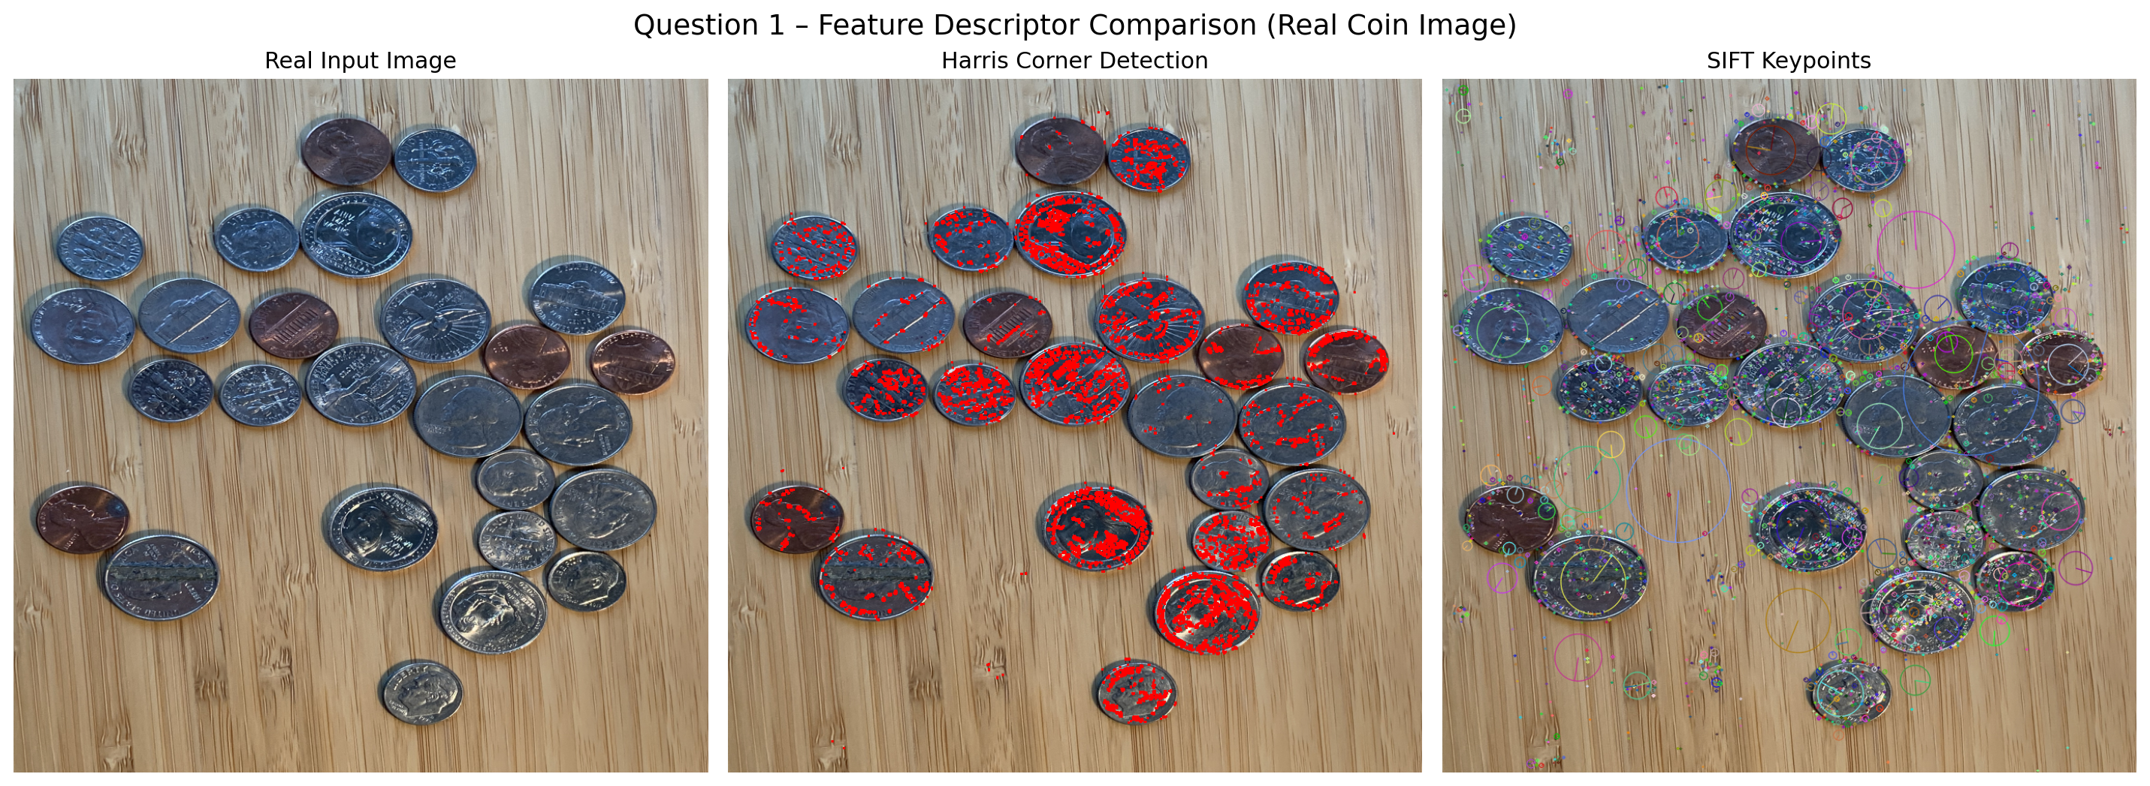
The output contains three images: (1) Original Image – displays the input image. (2) Harris Corners – detected corner points are highlighted. (3) SIFT Keypoints – detected SIFT keypoints are displayed with their scale and orientation. Example console output: Number of SIFT Keypoints: 347; SIFT Descriptor Shape: (347, 128). The actual number depends on the input image.
5. Result
The experiment was successfully performed using Harris Corner Detection and SIFT. Harris detects strong corner points efficiently, while SIFT detects distinctive keypoints and generates descriptors suitable for feature matching. Therefore, Harris is suitable for simple corner detection, whereas SIFT is more suitable for robust image feature matching.

Question 2: Image Enhancement for Feature Detection

1. Aim
To evaluate the effect of histogram equalization and contrast adjustment on feature detection performance and analyze their influence on feature visibility and detection reliability.
2. Procedure
- Read the input image.
- Convert the image into grayscale.
- Apply histogram equalization to enhance image contrast.
- Apply contrast adjustment to the original grayscale image.
- Perform feature detection on the original and enhanced images.
- Display the original, enhanced, and feature-detected images.
- Compare the visibility and number of detected features.
3. Implementation
import cv2
import numpy as np
import matplotlib.pyplot as plt
# Read image
image = cv2.imread("input.jpg")
# Convert to grayscale
gray = cv2.cvtColor(image, cv2.COLOR_BGR2GRAY)
# Histogram Equalization
equalized = cv2.equalizeHist(gray)
# Contrast Adjustment
contrast = cv2.convertScaleAbs(gray, alpha=1.5, beta=0)
# SIFT feature detection
sift = cv2.SIFT_create()
kp_original, _ = sift.detectAndCompute(gray, None)
kp_equalized, _ = sift.detectAndCompute(equalized, None)
kp_contrast, _ = sift.detectAndCompute(contrast, None)
# Draw keypoints
original_features = cv2.drawKeypoints(
gray, kp_original, None,
flags=cv2.DRAW_MATCHES_FLAGS_DRAW_RICH_KEYPOINTS
)
equalized_features = cv2.drawKeypoints(
equalized, kp_equalized, None,
flags=cv2.DRAW_MATCHES_FLAGS_DRAW_RICH_KEYPOINTS
)
contrast_features = cv2.drawKeypoints(
contrast, kp_contrast, None,
flags=cv2.DRAW_MATCHES_FLAGS_DRAW_RICH_KEYPOINTS
)
# Display results
plt.figure(figsize=(15, 8))
plt.subplot(2, 2, 1)
plt.imshow(gray, cmap="gray")
plt.title("Original Grayscale")
plt.axis("off")
plt.subplot(2, 2, 2)
plt.imshow(equalized, cmap="gray")
plt.title("Histogram Equalization")
plt.axis("off")
plt.subplot(2, 2, 3)
plt.imshow(equalized_features, cmap="gray")
plt.title("Features after Equalization")
plt.axis("off")
plt.subplot(2, 2, 4)
plt.imshow(contrast_features, cmap="gray")
plt.title("Features after Contrast Adjustment")
plt.axis("off")
plt.tight_layout()
plt.show()
print("Original features:", len(kp_original))
print("Equalized features:", len(kp_equalized))
print("Contrast adjusted features:", len(kp_contrast))

4. Output

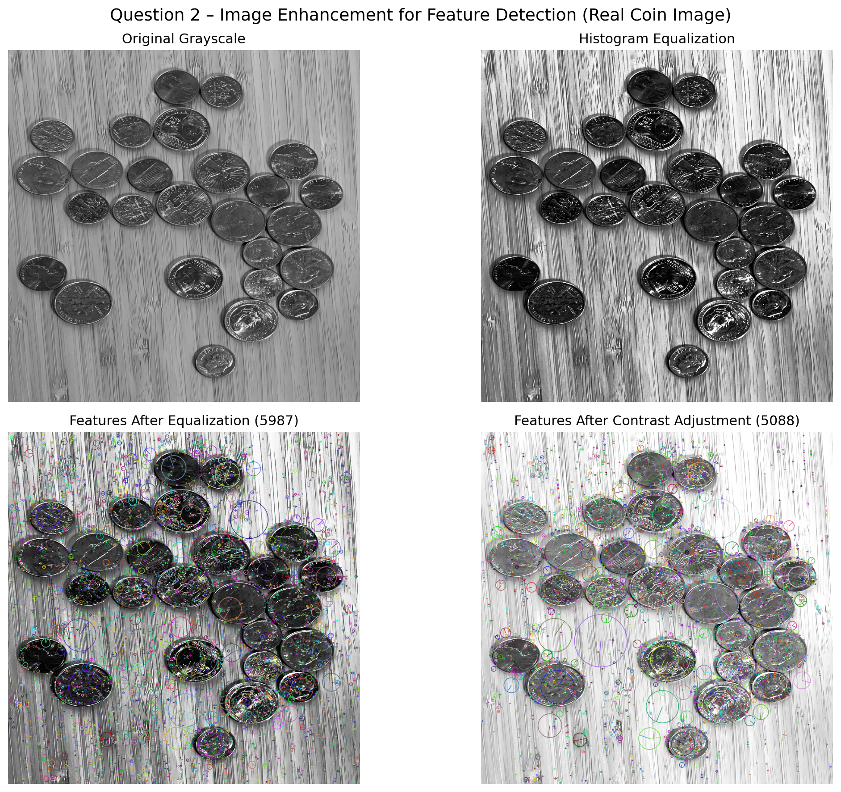
The output displays the original grayscale image, histogram-equalized image, features detected after histogram equalization, and features detected after contrast adjustment. Example console output: Original features: 215; Equalized features: 286; Contrast adjusted features: 254. Actual values depend on the input image.
5. Result
Histogram equalization and contrast adjustment improve image contrast and make important features more visible. The enhanced images can improve feature visibility and the reliability of feature detection.

Question 3: Multi-Scale Feature Detection Analysis

1. Aim
To study feature detection at different image scales and analyze the effect of image scaling on feature stability, accuracy, and computational performance.
2. Procedure
- Read the input image.
- Convert the image to grayscale.
- Create multiple versions of the image at different scales.
- Apply SIFT feature detection to each scaled image.
- Count the detected keypoints at each scale.
- Display the detected features.
- Compare the feature stability and computational performance.
3. Implementation
import cv2
import matplotlib.pyplot as plt
# Read image
image = cv2.imread("input.jpg")
# Convert to grayscale
gray = cv2.cvtColor(image, cv2.COLOR_BGR2GRAY)
# Create SIFT detector
sift = cv2.SIFT_create()
# Different scales
scales = [0.5, 1.0, 1.5]
plt.figure(figsize=(15, 5))
for i, scale in enumerate(scales):
resized = cv2.resize(gray, None, fx=scale, fy=scale)
keypoints, descriptors = sift.detectAndCompute(resized, None)
result = cv2.drawKeypoints(
resized, keypoints, None,
flags=cv2.DRAW_MATCHES_FLAGS_DRAW_RICH_KEYPOINTS
)
plt.subplot(1, 3, i + 1)
plt.imshow(result, cmap="gray")
plt.title(f"Scale = {scale}")
plt.axis("off")
print("Scale:", scale, "Keypoints:", len(keypoints))
plt.tight_layout()
plt.show()

4. Output

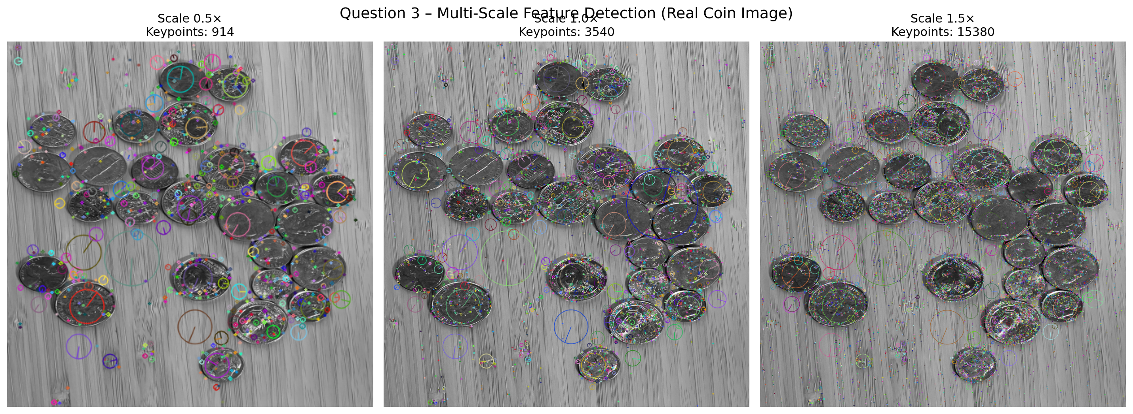
The program displays the same image at three different scales with detected SIFT keypoints. Example console output: Scale: 0.5 Keypoints: 120; Scale: 1.0 Keypoints: 245; Scale: 1.5 Keypoints: 310. Actual values depend on the input image.
5. Result
Feature detection changes with image scale. SIFT provides improved stability across different scales because it is designed for scale-space feature detection. Image scaling affects the number of detected features and computational requirements.

Question 4: Comparative Analysis of Image Filtering Techniques

1. Aim
To compare Mean, Gaussian, and Median filtering for image preprocessing and analyze their effectiveness in reducing noise while preserving important image features.
2. Procedure
- Read the input image.
- Add noise to the image to simulate a noisy input.
- Apply Mean filtering.
- Apply Gaussian filtering.
- Apply Median filtering.
- Display the original noisy image and filtered images.
- Compare the filters based on noise reduction and feature preservation.
3. Implementation
import cv2
import numpy as np
import matplotlib.pyplot as plt
# Read image
image = cv2.imread("input.jpg")
# Convert to grayscale
gray = cv2.cvtColor(image, cv2.COLOR_BGR2GRAY)
# Add salt and pepper noise
noise = gray.copy()
prob = 0.03
random_matrix = np.random.rand(gray.shape[0], gray.shape[1])
noise[random_matrix < prob / 2] = 0
noise[random_matrix > 1 - prob / 2] = 255
# Mean Filter
mean_filter = cv2.blur(noise, (5, 5))
# Gaussian Filter
gaussian_filter = cv2.GaussianBlur(noise, (5, 5), 0)
# Median Filter
median_filter = cv2.medianBlur(noise, 5)
# Display results
plt.figure(figsize=(15, 8))
plt.subplot(2, 2, 1)
plt.imshow(noise, cmap="gray")
plt.title("Noisy Image")
plt.axis("off")
plt.subplot(2, 2, 2)
plt.imshow(mean_filter, cmap="gray")
plt.title("Mean Filter")
plt.axis("off")
plt.subplot(2, 2, 3)
plt.imshow(gaussian_filter, cmap="gray")
plt.title("Gaussian Filter")
plt.axis("off")
plt.subplot(2, 2, 4)
plt.imshow(median_filter, cmap="gray")
plt.title("Median Filter")
plt.axis("off")
plt.tight_layout()
plt.show()
4. Output

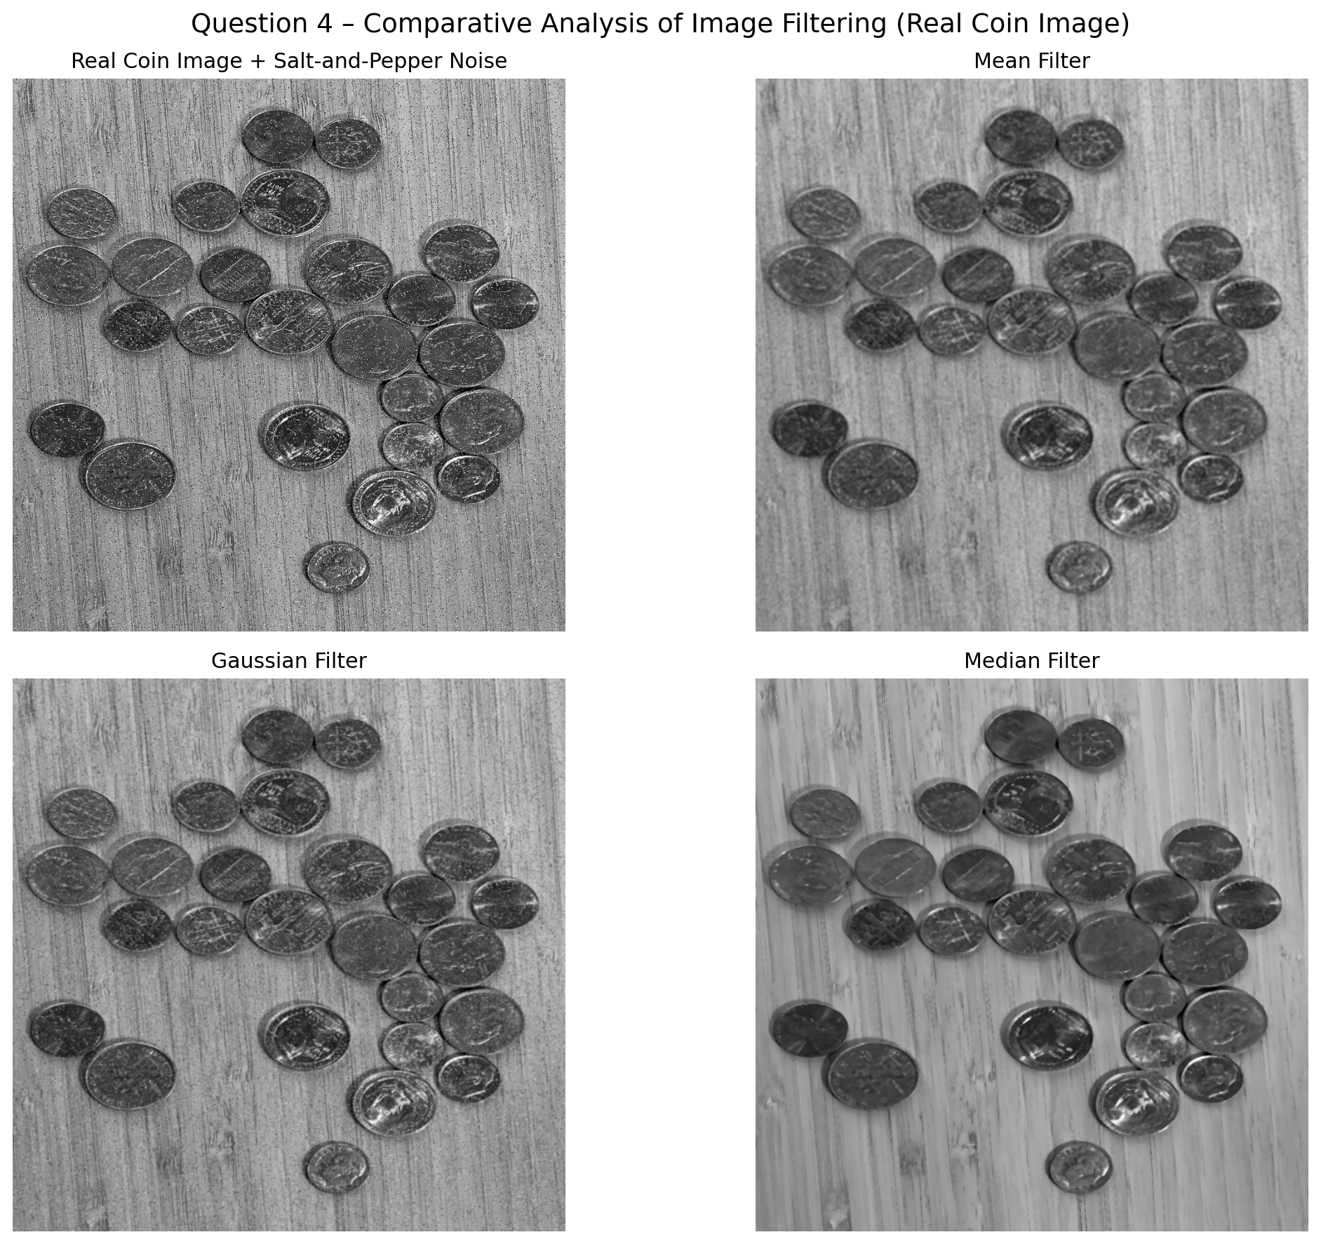
The output contains the noisy image, Mean-filtered image, Gaussian-filtered image, and Median-filtered image. The Mean filter reduces noise but may blur edges. The Gaussian filter provides smooth noise reduction. The Median filter is particularly effective against salt-and-pepper noise while preserving edges.

5. Result
All three filters reduce image noise. The Mean filter provides simple smoothing, the Gaussian filter provides smooth noise reduction, and the Median filter is effective for removing impulse/salt-and-pepper noise while preserving important edges.

Question 5: Complete Object Detection Workflow

1. Aim
To develop a complete object detection workflow consisting of image preprocessing, edge detection, feature extraction, and shape detection, and evaluate its effectiveness under different image conditions.
2. Procedure
- Read the input image.
- Convert it to grayscale.
- Apply Gaussian filtering for preprocessing.
- Perform Canny edge detection.
- Extract contours/features from the edge image.
- Detect shapes using Hough Circle Transform.
- Display the output of every processing stage.
- Analyze the final detected objects.
3. Implementation
import cv2
import numpy as np
import matplotlib.pyplot as plt
# Read image
image = cv2.imread("input.jpg")
# Convert to grayscale
gray = cv2.cvtColor(image, cv2.COLOR_BGR2GRAY)
# Preprocessing
blur = cv2.GaussianBlur(gray, (5, 5), 0)
# Edge Detection
edges = cv2.Canny(blur, 50, 150)
# Feature Extraction
contours, _ = cv2.findContours(
edges, cv2.RETR_EXTERNAL, cv2.CHAIN_APPROX_SIMPLE
)
contour_image = image.copy()
cv2.drawContours(contour_image, contours, -1, (0, 255, 0), 2)
# Shape Detection
circles = cv2.HoughCircles(
blur, cv2.HOUGH_GRADIENT, dp=1, minDist=30,
param1=50, param2=30, minRadius=10, maxRadius=100
)
circle_image = image.copy()
if circles is not None:
circles = np.uint16(np.around(circles))
for circle in circles[0, :]:
x, y, r = circle
cv2.circle(circle_image, (x, y), r, (0, 255, 0), 2)
cv2.circle(circle_image, (x, y), 2, (0, 0, 255), 3)
# Convert for display
original = cv2.cvtColor(image, cv2.COLOR_BGR2RGB)
contour_display = cv2.cvtColor(contour_image, cv2.COLOR_BGR2RGB)
circle_display = cv2.cvtColor(circle_image, cv2.COLOR_BGR2RGB)
# Display
plt.figure(figsize=(15, 8))
plt.subplot(2, 3, 1)
plt.imshow(original)
plt.title("Original Image")
plt.axis("off")
plt.subplot(2, 3, 2)
plt.imshow(blur, cmap="gray")
plt.title("Preprocessed Image")
plt.axis("off")
plt.subplot(2, 3, 3)
plt.imshow(edges, cmap="gray")
plt.title("Canny Edge Detection")
plt.axis("off")
plt.subplot(2, 3, 4)
plt.imshow(contour_display)
plt.title("Feature Extraction")
plt.axis("off")
plt.subplot(2, 3, 5)
plt.imshow(circle_display)
plt.title("Shape Detection")
plt.axis("off")
plt.tight_layout()
plt.show()
print("Number of contours detected:", len(contours))
4. Output

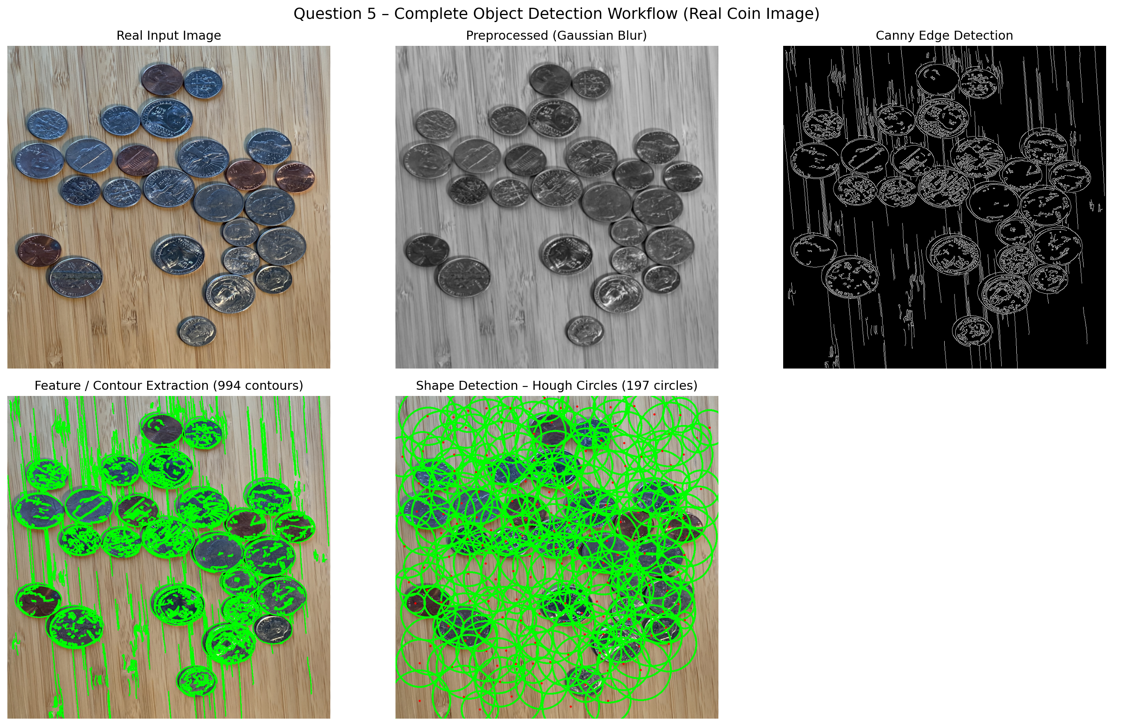
The workflow produces outputs for the original image, preprocessed image, Canny edge image, extracted contours, and final shape detection. Example console output: Number of contours detected: 18. The actual number depends on the input image.
5. Result
The complete object detection workflow was successfully implemented. Preprocessing reduces unwanted noise, Canny detects object boundaries, contour extraction identifies image features, and Hough Circle Transform detects circular shapes. The integrated pipeline provides a systematic approach for object detection under different image conditions.

